National Monument to the Forefathers, 1863, Design Overview
The design for the National Monument to the Forefathers, to be erected at Plymouth, consists of an octagon pedestal, on which stands a statue of Faith. From the four smaller faces of the pedestal project buttresses, upon which are seated figures emblematic of Morality, Education, Law, and Liberty. Below them, in panels, are alto-reliefs of " The Departure from Delfthaven," " The Signing of the Social Compact in the Cabin of the May Flower," " The Landing at Plymouth," and " The First Treaty with the Indians." Upon the four large faces of the main pedestal are large panels, to contain records of the principal events in the history of the Pilgrims, with the names of those who came over in the May Flower, and below are smaller panels for records connected with the society and the building of the monument,

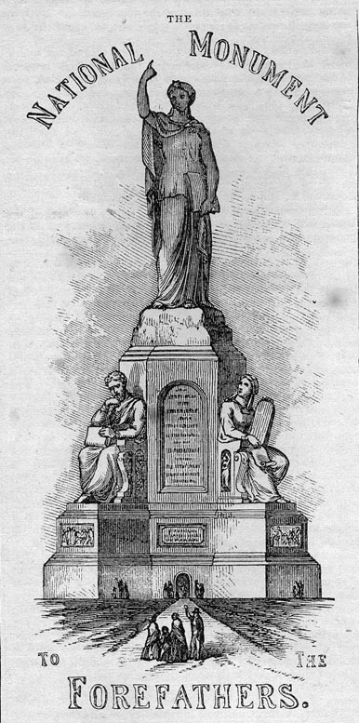
A chamber within the pedestal, 26 feet in diameter, and well lighted, is to be a depository for all documents, &c., relating to the pilgrims and the society, including an accurate record of the receipts and expenditures for the monument, and a list of the names of subscribers of $1 and over, arranged by states, counties, and towns, and alphabetically, so as to be easily referred to. In this chamber will be a stairway leading to the platform upon which stands the figure of Faith, from which may be seen all the places of interest connected with the history of the forefathers. The whole monument will be about 150 feet high, and 80 feet at the base. The Statue of Faith rests her foot upon the Forefather's Rock; in her left hand she , holds an open Bible; with the right uplifted she points to
heaven. Looking downward, as to those she is addressing, she seems to call them to trust in a higher power. The sitting figures are emblematic of the principles upon which the Pilgrims proposed to found their Commonwealth. The first of these is Morality. She holds the Decalogue in her left, and the Scroll of Revelation in her right hand. Her look is upward, towards the impersonation of the Spirit of Religion above. In a niche, on one side of her throne, is a Prophet, and in the other, one of the Evangelists. The second of these figures is Law. On one side of his seat is Justice; on the other, Mercy. The third is Education. In the niche on one side of her seat, is Wisdom, ripe with years; on the other, Youth, led by Experience. The fourth figure is Freedom. On one side, Peace rests under his protection; on the other, Tyranny is overthrown by his prowess.
The Statue of Faith will be 70 feet high, and the sitting figures 38 feet high, — thus making it in magnitude the greatest work of the kind in the world; while as a work of art, it will afford pleasure to every American citizen.

National Monument to the Forefathers
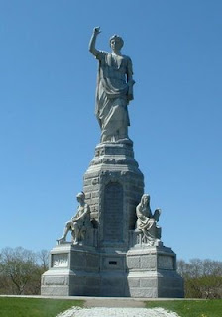
I wanted to follow up on Lindsey's interesting post regarding the place of Plymouth in American memory.
In the video she posted, the commentators are sitting in front of the impressive monument known as the National Monument to the Forefathers. This memorial, which historian James O'Gorman called, "one of the more lugubrious deposits of mid-nineteenth-century American ideals," was erected by the Pilgrim Society in the 1880s (planning began in the 1850s, but things got off track during the Civil War). The monument features a 36-foot tall granite colossus titled, Faith, surrounded by smaller (15-foot) allegorical statues depicting Liberty, Education, Law, and Morality, as well as several relief panels.
This statue is important because it reminds us that much of what we "know" about the Plymouth colonists and their role in founding the country comes from 19th-century efforts to recapture a usable past, not from rigorous historical investigations into the early 17th century. In the mid 19th century, New Englanders were busy fighting a sectional conflict for supremacy over the meaning of America, and one of the best weapons they had in their arsenal was the argument that the Pilgrims founded America on Christian principles. By ignoring those sordid mercenaries in Jamestown and exalting the Pilgrims as beacons of both religious piety and democracy, they strengthened their claim to the legacy of the forefathers, at the same time denying the legitimacy of Southern claims that the spirit of '76 lived on in the South.
This statue is a concrete (granite, actually ;)) expression of 19th-century interpretations of 17th-century history. Imagine what a monumental history of New England would have looked like if authored by Harriet Beecher Stowe. This is it.
The Victorian interpretation of 17th-century American history is still very much with us (it's even on the citizenship exam). I'll bet the average American "knows" 10x more about Plymouth than about any other 17th-century colony and thinks that the Pilgrims profoundly influenced our nation's democratic and religious institutions when they did nothing of the sort. The Mayflower Compact was not a principled clarion call to democracy. The Pilgrims were not big fans of religious toleration (as the intro video at Plimoth Plantation helpfully points out) and held no appreciable influence over any of their contemporaries, they didn't even influence Massachusetts' Congregational practices. Christianity was a major factor in English colonization, but not in the way 19th-c New Englanders thought.

